**DBMS PROJECT DOCUMENT**

BATCH - 1

Group 1 – Pratyush Patro (J047) , Namann Bhan (J007) , Vedik Gupta (J019) , Anmol Bhatia (J009) .

Topic – Database Management System of an Amusement Park

1. ER Diagram :-

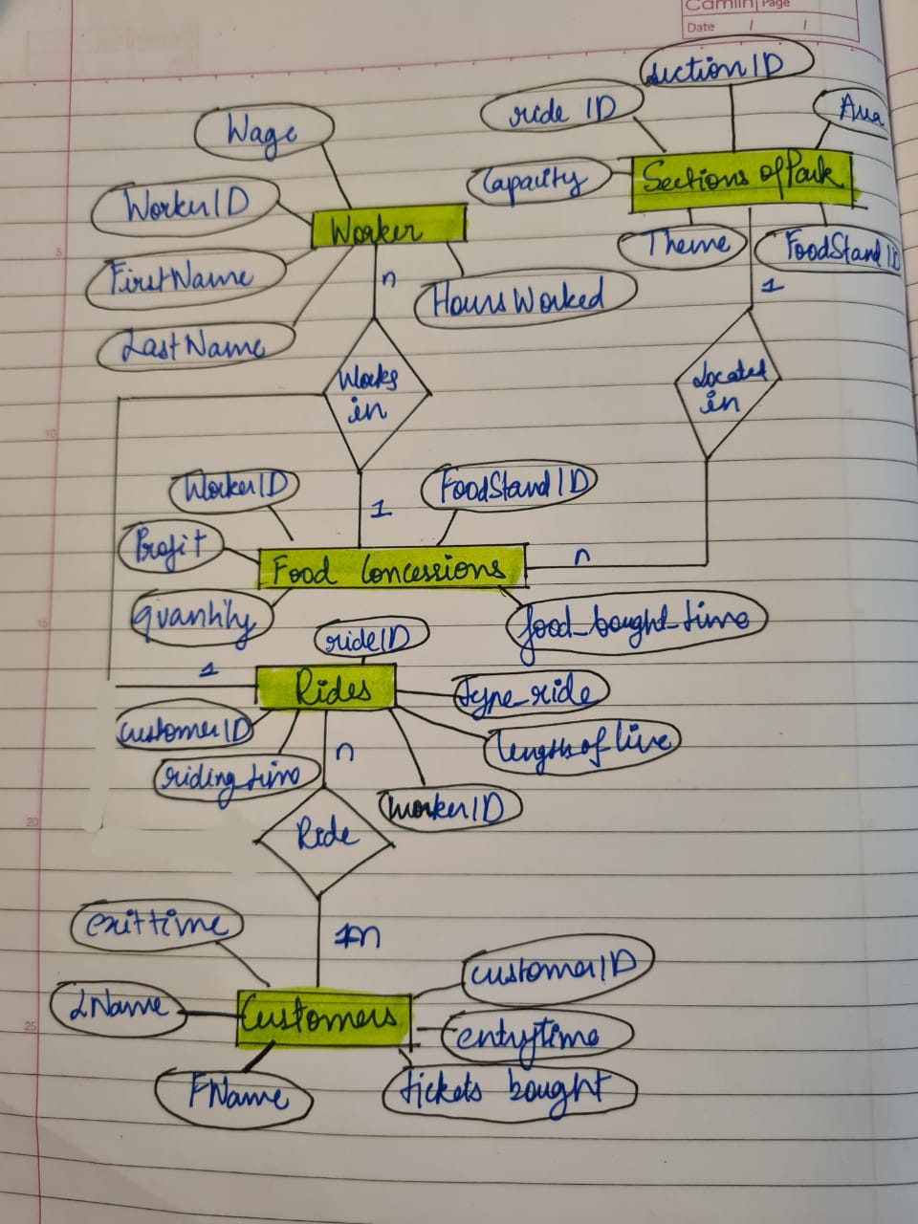

1. SQL Queries :-

-- CREATING DATABASE -

CREATE DATABASE IF NOT EXISTS DBMS_CASE_STUDY ;

USE DBMS_CASE_STUDY ;

-- CREATING TABLES -

create table IF NOT EXISTS Food_Concessions

(

foodStand_ID INTEGER PRIMARY KEY,

worker_ID integer,

profit decimal,

food_Type text,

quantity integer,

food_bought_time DATETIME

) ;

create table IF NOT EXISTS Customers

(

customer_ID integer PRIMARY KEY,

entry_time DATETIME,

exit_time DATETIME ,

ticketsBought integer,

fname_customer text,

lname_customer text

) ;

create table IF NOT EXISTS Sections_Of_Park

(

section_ID integer PRIMARY KEY,

ride_ID int,

foodStand_ID int,

theme text,

area text,

capacity integer

);

create table IF NOT EXISTS Rides

(

ride_ID integer PRIMARY KEY,

length_of_line int,

worker_ID integer,

type_ride text,

customer_ID integer,

riding_time datetime

);

create table IF NOT EXISTS Worker

(

worker_ID integer PRIMARY KEY,

fname_worker text,

lname_worker text,

wage decimal,

hours_worked decimal

) ;

-- ENTERING VALUES -

INSERT INTO Food_Concessions values(152,100,10.5,'salad',4,'2019-01-31 09:30:25');

INSERT INTO Food_Concessions values(160,102,11.5,'pizza',4,'2019-01-31 19:04:34');

INSERT INTO Food_Concessions values(156,103,13.5,'icecream',4,'2019-01-31 10:09:07');

INSERT INTO Food_Concessions values(168,104,17.5,'taco',4,'2019-01-31 16:18:08');

INSERT INTO Food_Concessions values(189,125,12.7,'Chicken wings',4,'2019-01-31 18:09:57');

INSERT INTO Customers values(2001,'2019-01-31 11:09:15','2019-01-31 14:09:15',5,'Namann','Bhan');

INSERT INTO Customers values(2050,'2019-01-31 12:04:50','2019-01-31 16:09:15',2,'Vedik','Gupta');

INSERT INTO Customers values(2078,'2019-01-31 10:30:21','2019-01-31 15:09:15',4,'Pratyush','Patro');

INSERT INTO Customers values(2008,'2019-01-31 16:31:56','2019-01-31 20:09:15',1,'Vinay','Hariya');

INSERT INTO Customers values(2058,'2019-01-31 17:45:52','2019-01-31 19:09:15',7,'Anmol','Bhatia');

INSERT INTO Customers(customer_ID,entry_time,ticketsBought,fname_customer,lname_customer)

values(2059,'2019-01-31 18:45:52',1,'Rohan','Mehra');

INSERT INTO Customers(customer_ID,entry_time,ticketsBought,fname_customer,lname_customer)

values(2055,'2019-01-31 18:46:02',3,'Karan','Mehta');

INSERT INTO Customers(customer_ID,entry_time,ticketsBought,fname_customer,lname_customer)

values(2077,'2019-01-31 18:48:12',2,'Shabeer','Sheikh');

INSERT INTO Customers(customer_ID,entry_time,ticketsBought,fname_customer,lname_customer)

values(2099,'2019-01-31 18:55:12',2,'Samay','Rao');

INSERT INTO Customers(customer_ID,entry_time,ticketsBought,fname_customer,lname_customer)

values(2098,'2019-01-31 18:56:17',2,'Bhuvan','Bhan');

INSERT INTO Customers(customer_ID,entry_time,ticketsBought,fname_customer,lname_customer)

values(2095,'2019-01-31 18:57:17',2,'Calvin','Pinto');

INSERT INTO Sections_Of_Park values(52,34,152,'Moroccon nights','adult','50');

INSERT INTO Sections_Of_Park values(78,37,160,'Christmas','roller coster','80');

INSERT INTO Sections_Of_Park values(62,26,156,'Snow world','children','30');

INSERT INTO Sections_Of_Park values(89,20,168,'Water Park','adult','10');

INSERT INTO Sections_Of_Park values(97,17,189,'Water Park','children','40');

INSERT INTO Rides values(34,40,100,'Gravitron',2001,'2019-01-31 10:33:01');

INSERT INTO Rides values(37,50,102,'Spinning Teacup',2050,'2019-01-31 16:21:39');

INSERT INTO Rides values(26,20,103,'Thunder',2078,'2019-01-31 17:06:12');

INSERT INTO Rides values(20,15,104,'Nitro',2008,'2019-01-31 18:19:31');

INSERT INTO Rides values(17,35,125,'Laser Tag',2058,'2019-01-31 15:50:47');

insert into Worker values (100, 'Virat', 'kohli', 10.25, 35 );

insert into Worker values (102, 'Phillipe', 'Smith', 8.25, 30 );

insert into Worker values (103, 'Harman', 'Singh', 9.25, 15 );

insert into Worker values (104, 'Harpreet', 'Chabba', 11.00, 35 );

insert into Worker values (125, 'Abish', 'Mathew', 11.25, 29 );

-- PRINTING TABLES -

select * from Food_Concessions ;

select * from Customers ;

select * from Sections_Of_Park ;

select * from Rides ;

select * from Worker ;

/*

*CREATING A TRIGGER WHICH GETS INVOKED WHEN A NEW CUSTOMER WANTS TO ENTER INTO THE AMUSEMENT PARK , i.e. BEFORE INSERTING A NEW ROW IN THE Customers TABLE . SO IT WILL CHECK IF THE CAPACITY OF THE PARK IS FULL , OR THERE IS SPACE FOR THE CUSTOMER TO GO . IN EITHER CASE IT DISPLAYS THE APPROPRIATE MESSAGE .*

*/

DELIMITER //

CREATE TRIGGER capacity_check

BEFORE INSERT

ON Customers

FOR EACH ROW

BEGIN

DECLARE capacity INT DEFAULT 0 ;

SET @result = "" ;

SET @total = (select count(*) FROM Customers) ;

SET @already_exited = (select count(exit_time) FROM Customers) ;

SET capacity = 5 ;

IF capacity > @total - @already_exited THEN

SET @result = "you can go in ! " ;

ELSEIF capacity <= @total - @already_exited THEN

SET @result = "park is full , wait for sometime ! " ;

END IF ;

END //

DELIMITER ;

SELECT @result ;

/*

*CREATING A TABLE WHICH WILL STORE THE DIFFERENCE OF THE NUMBER OF HOURS WORKED BY A WORKER IN A WEEK AND THE MINIMUM STANDARD NUMBER OF HOURS TO BE WORKED IN A WEEK , WHICH IS CONSIDERED AS 33 . THIS CALCULATION IS DONE IN AN AFTER INSERT TRIGGER BELOW WHICH GETS INVOKED AFTER ANY ROW IS INSERTED IN THE Worker TABLE .*

*/

CREATE TABLE IF NOT EXISTS workerhoursdifference(

worker_ID int ,

fname text,

lname text,

hours_workedDIFF decimal

);

DELIMITER $$

CREATE TRIGGER HOURSWORKEDDIFFERENCE

AFTER INSERT

ON Worker FOR EACH ROW

BEGIN

DECLARE difference decimal;

SET difference = NEW.hours_worked-33;

INSERT INTO workerhoursdifference VALUES(NEW.worker_ID ,NEW.fname_worker,NEW.lname_worker,difference);

END$$

DELIMITER ;